UDK: 711.45:004.127

COBISS.SR-ID: 11111111

DOI: 10.5281/zenodo.123456789

Categorization of paper (Style: Ariel Narrow, 8pt)

14pt

14pt

**Instructions for Authors**

(Style: Ariel Narrow, 14pt, Bold)

14pt

Name SURNAME1, Name SURNAME2, etc.

(Author's name, Co-author's name etc. - Style: Ariel Narrow, 10pt)

14pt

**Abstract:** The journal Smart Cities and modern technologies publishes scientific and professional papers in the area of mechanical, electrical and civil engineering and also their boundary areas. The submitted paper should not have been previously published elsewhere in the same or similar form and may not simultaneously be submitted to another journal for publication. The author is the only one responsible for the contents, data reliability and all the statements in the paper. The title of paper has no more than 15 words. Write full names and surnames of the authors, without grades and ranks. The abstract has not more than 200 words and it must reflect the content of the article more faithfully. It cites the methods used and highlights the achieved results as well as the contribution of the article without any symbols and units. Keywords are, as a rule, from the title of the article, and only from the abstract of the article. The article is not proofread and authors are responsible for the linguistic and grammatical correctness. After the review procedure is over, the authors may be asked to make certain corrections or additions to the article. (Style: Ariel Narrow, 8pt – you must erase text in brackets and also the brackets after finishing your paper).

8pt

**Keywords:** Alphabetic list of keywords in British English separated with; (Style: Ariel Narrow, 8pt)

10pt

10pt

## 1 INTRODUCTION (Introductory remarks)

## (Style: Ariel Narrow, 10pt, Bold)

10pt

Upon acceptance, the article is categorized as follows: original scientific paper, preliminary communication, review paper, and professional paper.

Original scientific papers should report original theoretical or practical research results. The data provided must be sufficient to enable the experiment to be replicated with all effects described by the author, including measurement results or theoretical calculations.

Preliminary communications present one or more new scientific results but without the details necessary to verify the reported data. These papers inform about experimental research, small research projects, or progress reports that are of interest.

Review papers cover the current state of knowledge and trends in the development of a specific theory, technology, and application, with commentary from the author. These papers conclude with a list of references that includes all necessary sources in the related field.

Professional papers report on the original design of an instrument, device, or equipment, which may not necessarily result from original research. Such papers contribute to the application of well-known scientific results and their adaptation for practical use.

The Editorial Board welcomes topics and research, which covers manufacturing procedures, experiences with specific equipment applications, and similar topics. The author should propose and provide arguments for the category of the submitted article. Papers presented at scientific conferences may also be published in the journal with the agreement of the conference organizer and the author.

Papers to be published in the journal SMART CITIES AND MODERN TECHNOLOGIES can be written in Serbian or English. The metrology and terminology used in the paper must comply with legal regulations, standards, and the International System of Units (SI).

10pt

**1.1 Subtitle 1 (Writing Instructions)**

(Style: Ariel Narrow, 10pt, Bold)

10pt

(Tab 6mm) The text of the paper is arranged in sections and when necessary into subsections. Sections are marked with one Arabic numeral and subsections with two Arabic numerals, e.g. 1.1, 1.2, 1.3, ... When a subsection is arranged in smaller parts, each of them is marked with three Arabic numerals, e.g. 1.1.1, 1.1.2, ... Further divisions are not allowed.

10pt

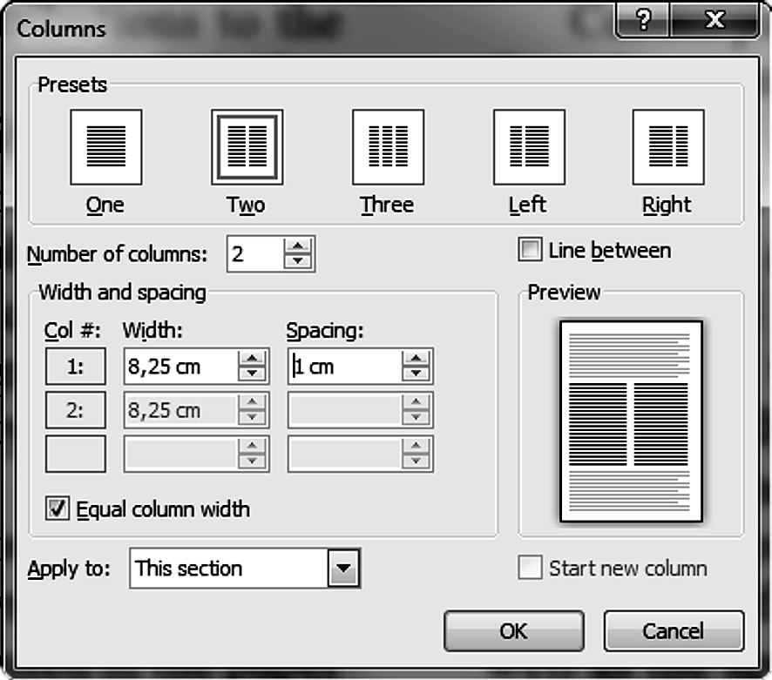

**Figure 1** The texts under figures

(Style: Ariel Narrow, 8pt)

10pt

The text has to be organized in the following order:

ISSN and https://doi.org/number/ID

Title of the paper (not more than 15 words). Papers should be headed by a concise but informative title that clearly reflects the subject of the paper. Authors' full names (without grades and ranks).

Abstract (not more than 200 words) should present a brief and factual account of content and conclusions of the paper, and an indication of the relevance of the new material presented.

Alphabetic list of keywords in English. Keywords normally originate from the title and from the abstract (use; between keywords).

Introduction should state the reason for the work, with brief reference to previous work on the subject. It informs about the applied method and its advantages.

Central part of the paper may be arranged in sections. Complete mathematical procedures for formula derivations should be avoided. The necessary mathematical descriptions may be given in an appendix. Authors are advised to use examples to illustrate the experimental procedure, applications or algorithms. In general, all the theoretical statements have to be experimentally verified.

In Conclusions all the results are stated, and all the advantages of the used method are pointed out. The limitations of the method should be clearly described as well as the application areas.

List of references should be brought together at the end of the article and numbered in square brackets in order of their appearance in the text followed by other literature.

Authors' full names (with grades and ranks) followed by the name and address of the institution in which the work was carried on.

A List of used symbols and their SI units is optional after the list of references.

10pt

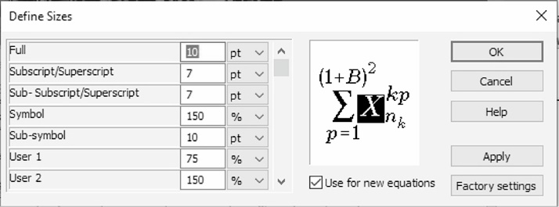

**Figure 2** The texts under figures

(Style: Ariel Narrow, 8pt)

10pt

**1.1.1 Subtitle 2 (Preparation of Manuscript)**

(Style: Ariel Narrow, 10pt, Bold)

10pt

The paper should be written using Latin characters. Greek letters may be used for symbols. The volume of the article is limited to 8 pages (A4 format). That includes blanks and equivalent number of characters covered by figures and tables. Number of pages must be even.

The text should be sent to the Editorial Board using e-mail. For the text preparing may be used only MS Word for Windows respectively *.doc, *.docx (Word Document) format of records. The text has to be prepared in accordance with this template.

Latin or Greek characters in italics are used for physical symbols and normal characters for measuring units and numerical values. Text in figures is also written with normal letters.

All figures in the Journal will be printed in black and white technique. Coloured figures will be seen only in the PDF format on the Web address

https://alfa.edu.rs/fakultet-informacionih-tehnologija-journal/.

Tables are created with the word processing program. Each table is positioned in the desired place in the text. In the case of decimal numbers use comas (e.g. 0,253); use a small gap separating the thousands (e.g. 25.000, but not in the case of 1500).

The texts under figures and table titles are only in the English language.

Section titles and titles of subsections are typed in small letters only in the English language. Equations are numbered with Arabic numerals in parenthesis at the right margin of the text. In the text an equation is referenced by its number in parenthesis like "... from Eq. (5) follows ...".

Create equations with **MathType** Equation Editor (some examples are given below) (adjustments of sizes see Fig. 2).

10pt

 (1)

 (2)

$W={(ω_{1},ω_{2},…,ω_{n})}^{T}$ (3)

10pt

(Notice: Equation Editor (Microsoft Equation 3.0) was included in previous versions of Word but has removed from all versions that have installed the January 2018 Public Update (PU)).

10pt

**Figure 3** The texts under figures [7]

10pt

Figures and tables are numbered with Arabic numerals (1 ÷ *n*) (symbol ÷ is used instead of "from … to …"). In the text in figure or table is referenced by its number (e.g. in Fig. 1, in Tab. 1, etc.).

When reference to literature is made the publication number from the list of references in square brackets is used like "... in [7] the authors showed ...". In the list of references literature is cited in accordance with APA (see http://www.bibme.org/citation-guide/apa/).

10pt

**2 COPYRIGHT TRANSFER AGREEMENT**

10pt

**Copyright assignment.** The author hereby assigns to the journal *Smart Cities and modern technologies* (SC&MT) the copyright in the above article (for U. S. government employees: to the extent transferable), throughout the world, in any form, in any language, for the full term of copyright, effective upon acceptance for publication. *Smart Cities and modern technologies* is an Open Access journal. All content is made freely available. Users are allowed to copy and redistribute, and alter, transform, or build upon the material as long as they attribute the source in an appropriate manner.

**Author's warranties.** The author warrants that the article is original, written by stated author/s, has not been published before and it will not be submitted anywhere else for publication prior to acceptance/rejection by SC&MT, contains no unlawful statements, does not infringe the rights of others, and that any necessary written permissions to quote from other sources have been obtained by the author/s.

**Rights of authors.** Authors retain the following rights:

- all proprietary rights relating to the article, other than copyright, such as patent rights,

- the right to use the substance of the article in future own works, including lectures and books,

- the right to reproduce this article for own purposes, provided the copies are not offered for sale.

10pt



**Figure 4** Page setup (paper size A4)

10pt

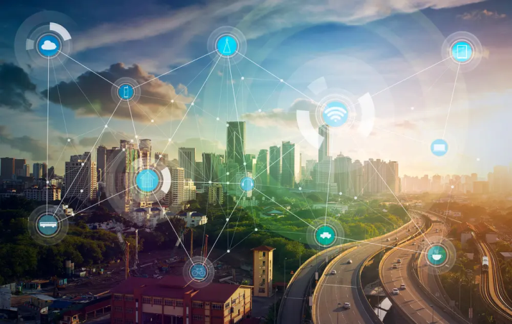

**Figure 5** Photography resolution of 300 dpi (min)

10pt

An author may self-archive an author-created version of his/her article on his/her own website and or in his/her institutional repository. He/she may also deposit this version on his/her founder’s or founder's designated repository at the founder's request or as a result of a legal obligation, provided it is not made publicly available until 12 months after official publication. Furthermore, the author may only post his/her version provided acknowledgement is given to the original source of publication and a link is inserted to the published article on <https://alfa.edu.rs/fakultet-informacionih-tehnologija-journal/>. He/she may use the publisher's PDF version, which is posted on https://alfa.edu.rs/fakultet-informacionih-tehnologija-journal/, for the purpose of self-archiving or deposit. Any other use of the article requires permission from the publisher.

**Co-authorship.** If the article was prepared jointly with other authors, the signatory of this form warrants that he/she has been authorized by all co-authors to sign this agreement on their behalf, and agrees to inform his/her co-authors of the terms of this agreement.

10pt

**3 PUBLICATION ETHICS AND PUBLICATION MALPRACTICE STATEMENT**

10pt

The publication of an article in a peer-reviewed journal is a critical model for *SMART CITIES AND MODERN TECHNOLOGIES*. It is essential to establish and adhere to standards of ethical behavior for all individuals involved in the publication process, including the author, the journal editor, the peer reviewer, and the publisher. The ethical guidelines followed by the journal are based on the Best Practice Guidelines for Journal Editors established by COPE (Committee on Publication Ethics).

**Publication Decisions:** The editor of *SMART CITIES AND MODERN TECHNOLOGIES* is responsible for deciding which articles submitted to the journal should be published. These decisions may be influenced by the policies of the journal's editorial board and must adhere to current legal requirements, such as those concerning libel, copyright infringement, and plagiarism. Editors may consult with other editors or reviewers in the decision-making process.

**Fair Play:** Manuscripts are evaluated solely based on their intellectual content, without regard to the race, gender, sexual orientation, religious beliefs, ethnicity, citizenship, or political views of the authors.

**Confidentiality:** Editors and their staff are obligated to keep all information regarding a submitted manuscript confidential. This information may only be disclosed to the corresponding author, reviewers, potential reviewers, other editorial advisers, and the publisher, as necessary.

**Disclosure and Conflicts of Interest:** Editors must not use any unpublished materials from submitted manuscripts in their own research without the explicit written permission of the author.

**Contribution to Editorial Decisions:** Peer review plays an integral role in assisting the editor with editorial decisions. Additionally, through feedback and communication with the author, peer review helps improve the quality of the paper.

**Acknowledgement of Sources:** Reviewers are responsible for identifying relevant published work that has not been cited by the authors. Any claim that a particular observation, derivation, or argument has already been reported must be accompanied by the appropriate citation. Reviewers should also alert the editor to any significant overlap or similarity between the manuscript under review and other published works of which they are personally aware.

The previous section, including **Fair Play**, **Confidentiality**, **Disclosure and Conflicts of Interest**, **Contribution to Editorial Decisions**, and **Acknowledgement of Sources**, remains valid.

10pt

**Table 1** Table titles (Style: Ariel Narrow, 8pt)

|  |  |  |  |
| --- | --- | --- | --- |
| Smart city | Smart city | Smart city | Smart city |
| 250,0 | 0,00 | 250,8 | 0,00 |
| 250,0 | 0,21 | 250,8 | 0,21 |
| 285,7 | 1,35 | 290,0 | 1,34 |
| 322,7 | 2,13 | 330,1 | 2,10 |
| 358,4 | 3,06 | 370,0 | 3,00 |
| 393,1 | 4,35 | 411,0 | 4,24 |
| 423,6 | 6,05 | 450,1 | 5,85 |
| 449,7 | 8,76 | 490,1 | 8,36 |

(Style in table: Times New Roman, 9pt, Normal)

10pt

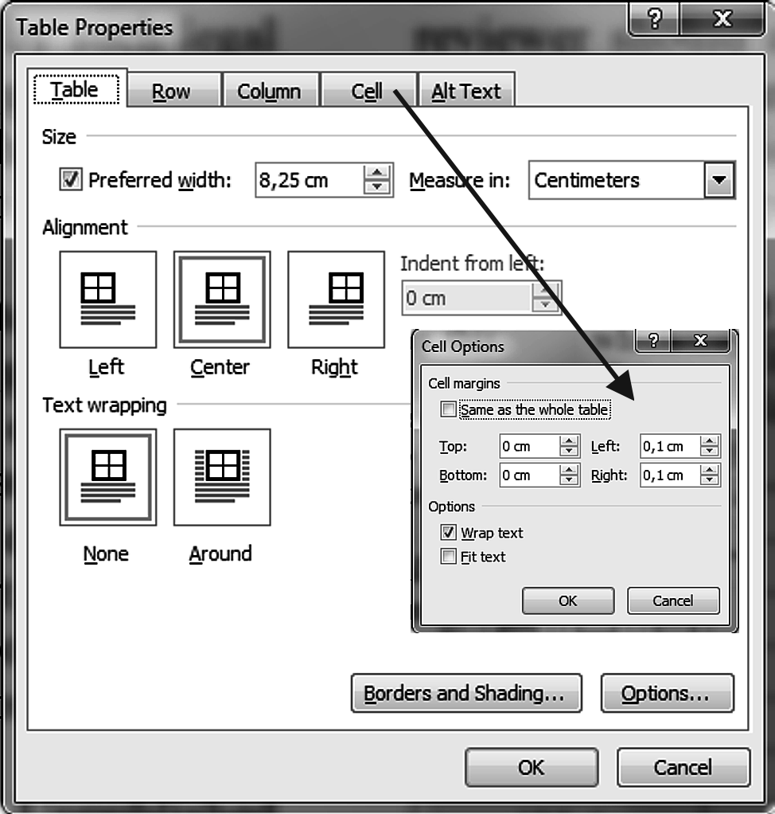

**Figure 6** Table properties

10pt

**Table 2** Table titles [4]

|  |  |  |  |  |  |  |  |
| --- | --- | --- | --- | --- | --- | --- | --- |
| 1 | 2 | 3 | 4 | 5 | 6 | 7 | 8 |
| Row | *Governance (G)* | *Mobility (M)* | *Environment (O)* | *Economy(E)* | *Citizens (C)* | *Livability (L)* |  |
| 1 | 50 | 4 | 239 | 1.563.600 | 267 | 1.564.500 | 0,06 |
| 2 | 10 | 5 | 179 | 324.030 | 267 | 327.540 | 1,08 |
| 3 | 15 | 6 | 148 | 185.150 | 267 | 190.310 | 2,79 |
| 4 | 20 | 7 | 130 | 131.280 | 267 | 137.680 | 4,87 |
| 5 | 25 | 8 | 116 | 102.540 | 267 | 109.920 | 7,20 |
| 6 | 30 | 9 | 106 | 84.607 | 267 | 92.824 | 9,71 |

(Style in table: Times New Roman, 9pt, Normal)

10pt

**x CONCLUSION**

10pt

Paper manuscripts, prepared in accordance with these Instructions for Authors, are to be submitted to the Editorial Board of the SMART CITIES AND MODERN TECHNOLOGIES journal. When being prepared for printing the text may undergo small alternations by the Editorial Board. Papers not prepared in accordance with these Instructions shall be returned to the first author. When there are several authors the first author is to be contacted. The Editorial Board shall accept the statements made by the first author.

The author warrants that the article is original, written by stated author/s, has not been published before and it will not be submitted anywhere else for publication prior to acceptance/rejection by SMART CITIES AND MODERN TECHNOLOGIES (SC&MT), contains no unlawful statements, does not infringe the rights of others, and that any necessary written permissions to quote from other sources have been obtained by the author/s.

10pt

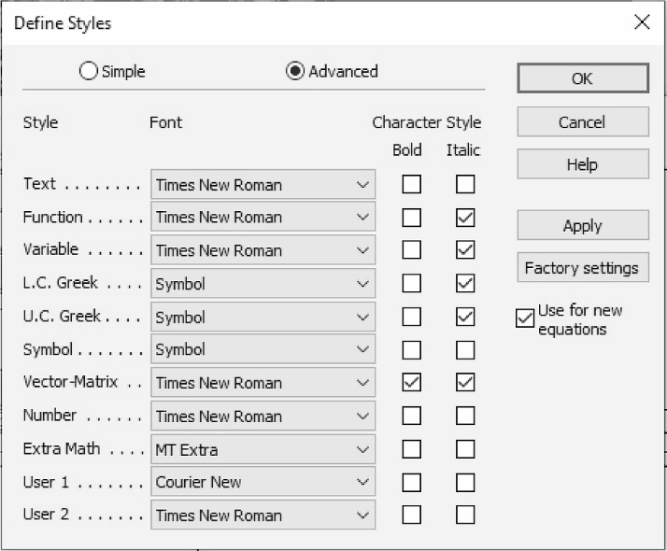

**Figure X** The texts under figures

(Style: Ariel Narrow, 8pt)

10pt

### x.1 How long does the review process take?

10pt

Most papers will be reviewed by two or more independent reviewers. They may also be read and considered by members of the Journal's Editorial Board and ultimately by the editor(s) before the decision is rendered. The reviewers are professionals working in the respective field, who are also writers of papers themselves. They offer their time and their expertise voluntarily in order to assist in improving the papers and to encourage new research in their topic of interest. Delays will inevitably occur when reviewers are busy. They may have a number of journals sending them papers to be reviewed. Our Journal may also receive large quantities of submissions throughout the year. The Editorial Board members of our Journal work tirelessly to ensure that peer reviews are as timely and rigorous as possible. Waiting times can vary, depending on the subject area.

10pt

10pt

**Acknowledgements**

10pt

**xx REFERENCES** (According to APA)

10pt

[1] See http://www.bibme.org/citation-guide/apa/

[2] See http://sites.umuc.edu/library/libhow/apa_examples.cfm

[3] (Style: Times New Roman, 9pt, according to APA)

[4] Amidzic, O., Riehle, H. J., & Elbert, T. (2006). Toward a psychophysiology of expertise: Focal magnetic gamma bursts as a signature of memory chunks and the aptitude of chess players. *Journal of Psychophysiology, 20*(4), 253-258. https://doi.org/10.1027/0269-8803.20.4.253

[5] Reitzes, D. C. & Mutran, E. J. (2004). The transition to retirement: Stages and factors that influence retirement adjustment. *International Journal of Aging and Human Development, 59*(1), 63-84. Retrieved from http://www.baywood.com/journals/PreviewJournals.asp?Id=0091-4150

[6] Jans, N. (1993). *The last light breaking: Life among Alaska's Inupiat Eskimos*. Anchorage, AK: Alaska Northwest Books.

[7] Miller, J. & Smith, T. (Eds.). (1996). *Cape Cod stories: Tales from Cape Cod, Nantucket, and Martha's Vineyard*. San Francisco, CA: Chronicle Books.

[8] Chaffe-Stengel, P. & Stengel, D. (2012). *Working with sample data: Exploration and inference*.

https://doi.org/10.4128/9781606492147

[9] Freitas, N. (2015, January 6). People around the world are voluntarily submitting to China’s Great Firewall. Why? Retrieved from http://www.slate.com/blogs/future_tense/ 2015/01/06/tencent_s_wechat_worldwide_internet_users_are_voluntarily_submitting_to.html

10pt

10pt

**Contact information:**

**Name SURNAME 1**, grades and ranks

(Corresponding author)

Year of birth

Institution

Postal address

1. Mail

https://orcid.org/0000-0002-9524-XXXX

**Name SURNAME 2**, grades and ranks

Year of birth

Institution

Postal address

1. Mail

https://orcid.org/0000-0002-9524-XXXX